Project Design Phase-I SolutionArchitecture

|  |  |
| --- | --- |
| Date | 06October2022 |
| TeamID | PNT2022TMID28599 |
| ProjectName | VirtualEye- LifeGuardforSwimmingPoolstoDetectActiveDrow ning |
| MaximumMarks | 4Marks |

SolutionArchitectureDiagram:

Solution architecture is a complex process – with many sub-processes – that bridges the gap between business problems and technology solutions. Its goals are to:

* **Find the best tech solution to solve existing business problems**
* **Describe the structure, characteristics, behavior, and other aspects of the software to project stakeholder**
* **Define features, development phases, and solution requirements**
* **Provide specifications according to which the solution is defined, managed, and delivered**

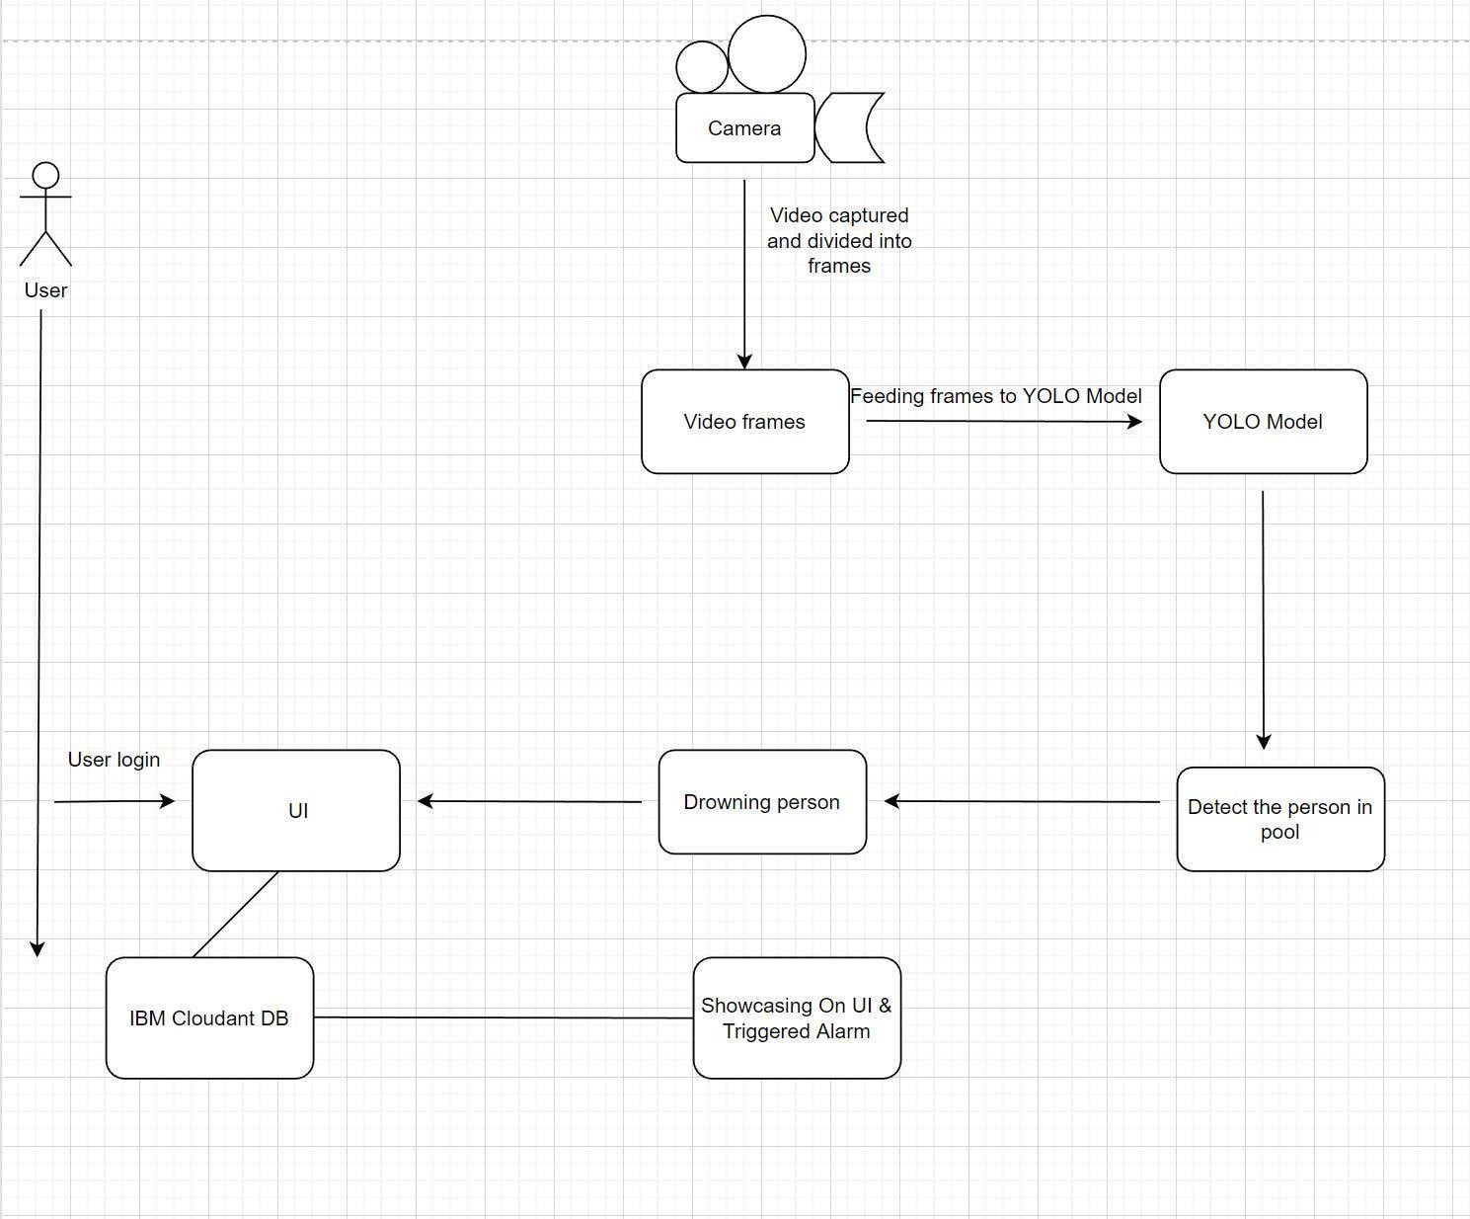

***Figure1:ArchitectureDiagram***